|  |  |
| --- | --- |
| *Pacific Gas and Electric Company* | |
| Release 8.2 Installation Guide | |
|  |  |
|  |  |
| Project | ED AM/GIS |
|  |  |
| Prepared by | Ashish Narasimham |
| Date | 5/22/2014 |
| Version | 1.1 |
| Version Type | Final |

|  |  |  |  |
| --- | --- | --- | --- |
| Revision History | | | |
| Document # | Date | Author | Summary of Changes |
| 1.0 |  | Ashish Narasimham | Initial Document Creation |
| 1.1 | 5/22/2014 | Roger Carribine | Removed UFM components being implemented in a different release |

# Introduction

## Purpose

This document is intended to detail the implementation and configuration steps required to implement Release 8.2 Installation Guide. This document describes the various configuration aspects required to complete any manual or automatic patch associated with this release. Each section in this document contains the steps required to patch the system in production.

## Terms Used

|  |  |
| --- | --- |
| OOTB | Out of the box. Unmodified from the commercial version. |
| TFS | Team Foundation Server |

## External Documents

Referenced are any external configuration documents or exports. These are documents that contain more detailed information about configuring a system or documents that can be loaded into an application to perform the configuration detailed in this document.

## Summary of Steps to Complete Patch

These are the high-level steps to complete the installation and configuration of the data model patch. Use this table as a guide for completing the installation. Links are provided that can lead either within the document for detailed explanations or to external sites such as Sharepoint.

Table of Contents

1 Introduction 3

1.1 Purpose 3

1.2 Terms Used 3

1.3 External Documents 3

1.4 Summary of Steps to Complete Patch 4

2 Open a Database Connection in ArcCatalog 5

3 Create Classes/Fields 6

3.1 Create the following feature classes in the UFMDataset: 6

4 Assign Model Names and AUs 17

5 Update Data Model Version Table 18

6 Known Issues 19

# Open a Database Connection in ArcCatalog

1. Open ArcCatalog.
2. Within the Catalog Tree, expand “Database Connections” and open the active connection for this process. This is the connection that is referenced in the change request associated with this document (EDGIS<DB name in the format X#Y> )

# Create Classes/Fields

## Create the following feature classes in the UFMDataset:

1. DuctAnnotation
   * 1. Follow the below screens to create this new annotation feature class:

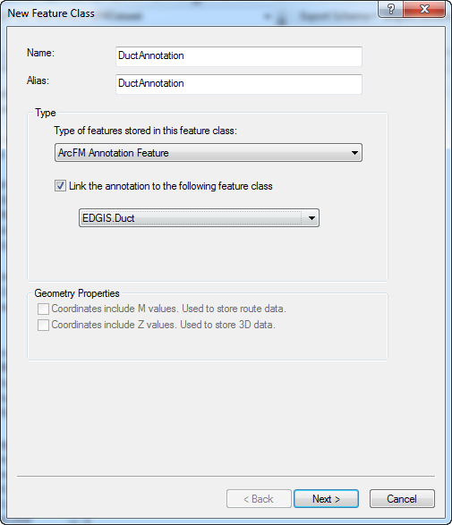

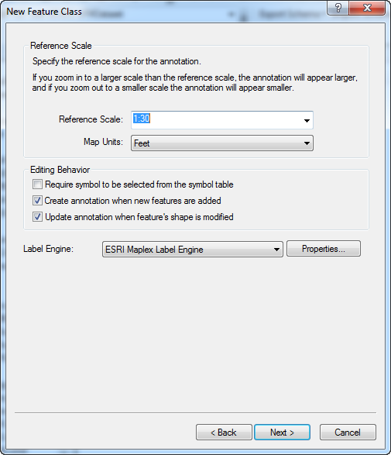

* + 1. No additional changes are required. Click next through the below screens and finish.  
       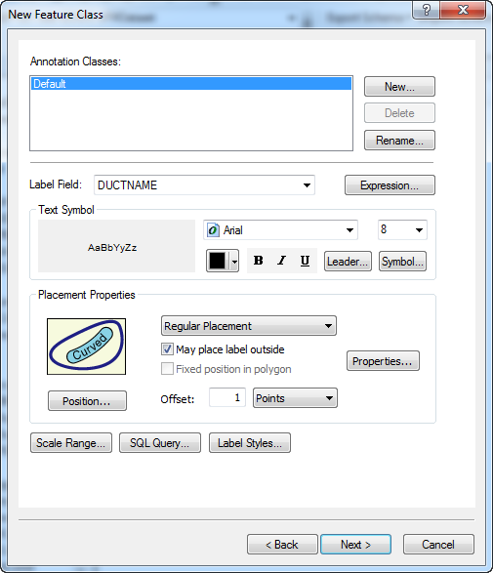  
       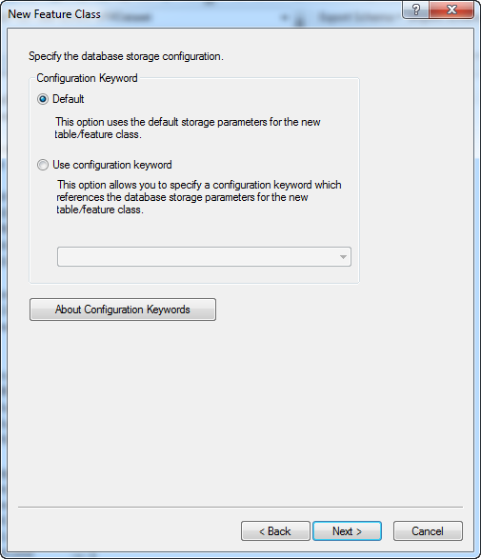

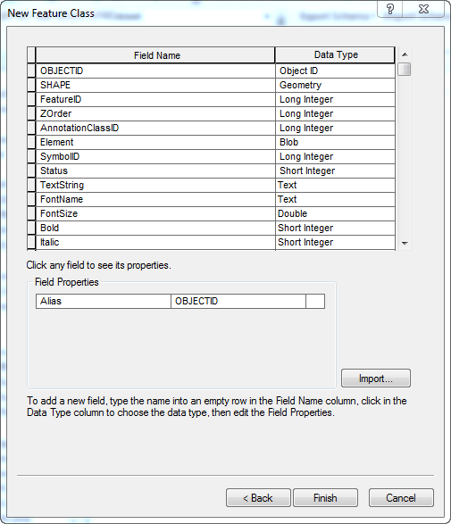

* + 1. Rename the relationship to “DuctAnnoRel”

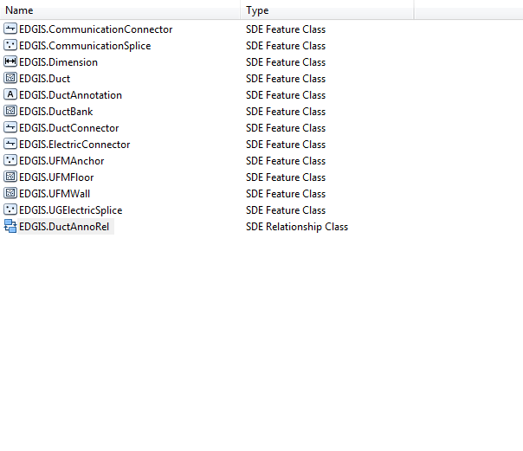

1. DuctBankAnchor
   * 1. Follow the below screens to create this feature class  
        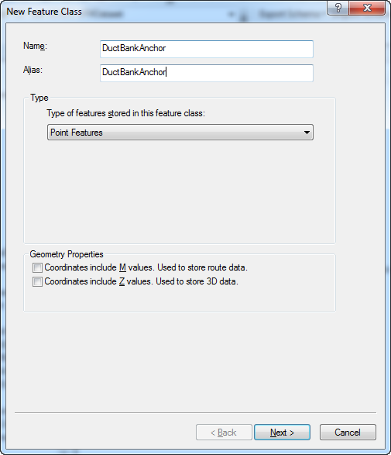  
        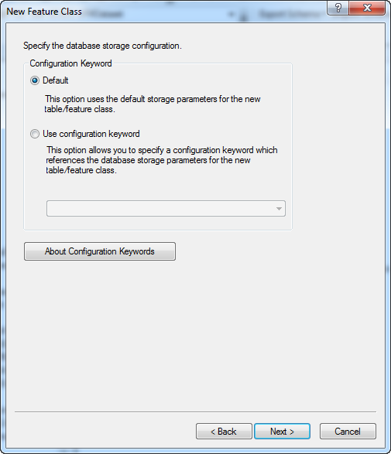
     2. Add the SymbolRotation field following the below screenshot:  
        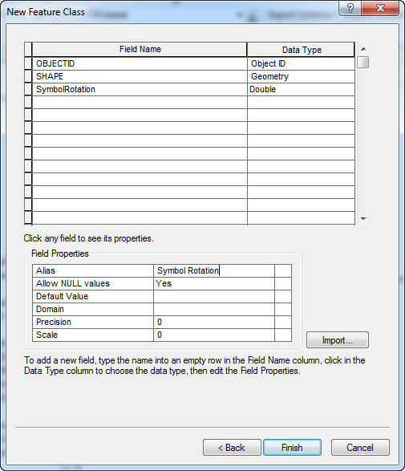
     3. Click Finish to create the feature class
2. DuctNoteAnno
   * 1. Use the below screens to create the feature class:  
        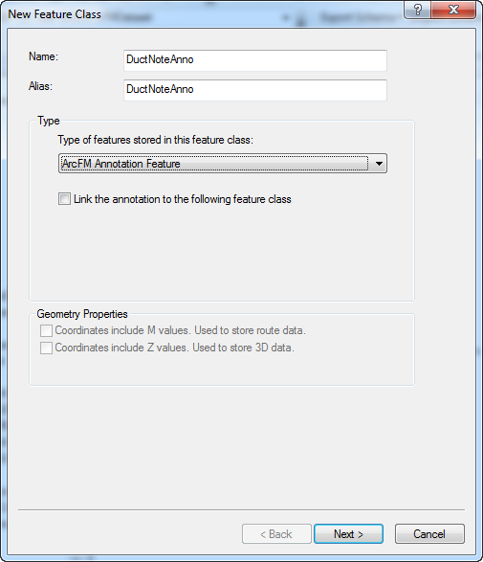   
        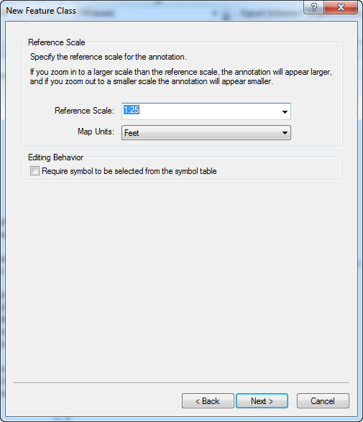
     2. No more changes are required. Press next to completion on the following screens.  
        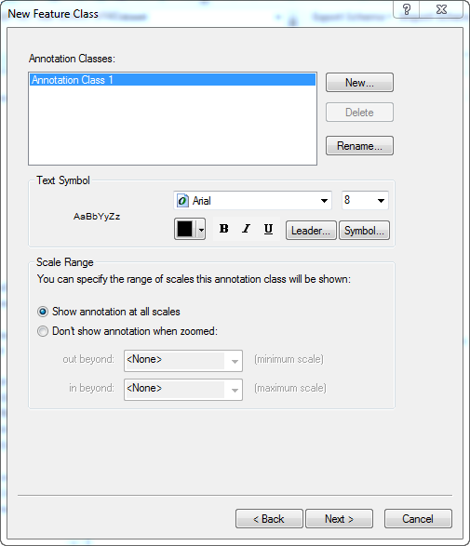  
        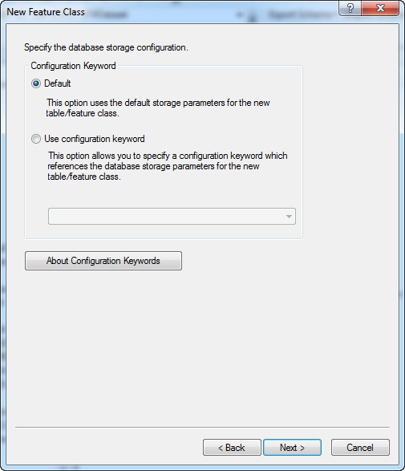  
        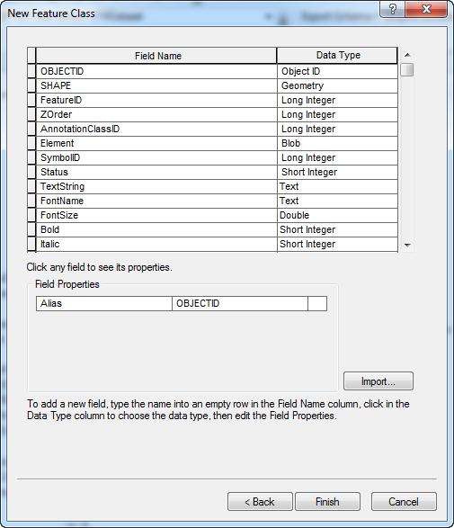
3. UFMInsetFrameSource
   1. Follow the below screens to create the feature class:  
      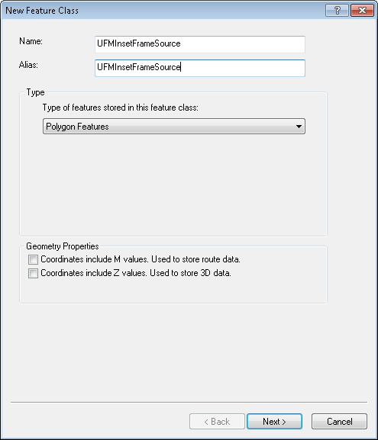
   2. No additional screens need to be changed. Click next through all below screens to completion.  
      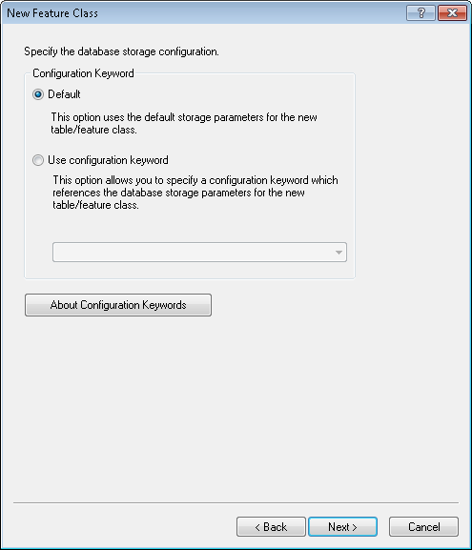  
      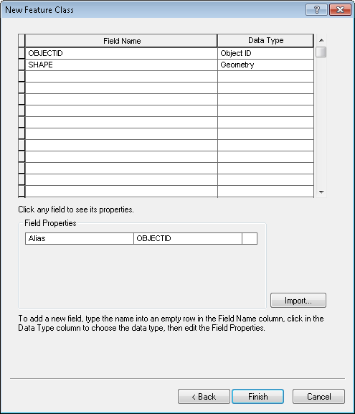

# Assign Model Names and AUs

1. Assign the following object level model names, autoupdaters, and properties on the following object classes:
   1. DuctAnnotation
      1. Model name – UFMANNOTATION
      2. Model name – UFMVISIBLE
   2. DuctBankAnchor
      1. Model name – UFMDUCTBANKANCHOR
      2. Model name – UFMVISIBLE
      3. Property – Split On Edit: No
   3. DuctNoteAnno
      1. Model name - UFMANNOTATION
      2. Model name - UFMVISIBLE
   4. UFMAnchor
      1. Model name - UFMANCHOR
      2. Model name – UFMVISIBLE
      3. Property – Split On Edit: No
   5. UFMInsetFrameSource
      1. Model name – INSETFRAMESOURCE
      2. Model name – UFMINSETFRAMESOURCE
2. Assign the following field level model names to the following object class/field combinations:
   1. DuctBankAnchor
      1. SymbolRotation: SYMBOLROTATION
   2. DuctConnector
      1. PhaseDesignation: PHASEDESIGNATION
   3. UFMAnchor
      1. SymbolRotation: SYMBOLROTATION
   4. UFMInsetFrameSource (add title (text 20) field to UFMInsetFrameSource)
      1. Title: INSETFRAMETITLE

# Update Data Model Version Table

**Database Configuration:**

1. Open SQL Plus.
2. Log in using the same server and user as was used in section 2.  
     
   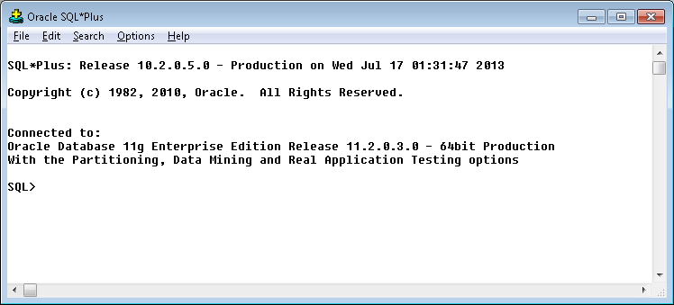
3. Run the SQL below:

update pgedatamodelversion set currentidc='N' where currentidc='Y';

insert into pgedatamodelversion (OBJECTID, CURRENTIDC, DATEAPPLIED, APPLIEDBYPERSONNAME, MODELVERSION) values (**INSERT NEXT VALID ID**,'Y',sysdate,'**<INSERT TEAM MEMBER DONE BY>**','**<INSERT DM VERSION>** GOLD **CR<INSERT CR NUMBER>**');

commit;

# Known Issues

<Please List any other issues encountered here while following the document>